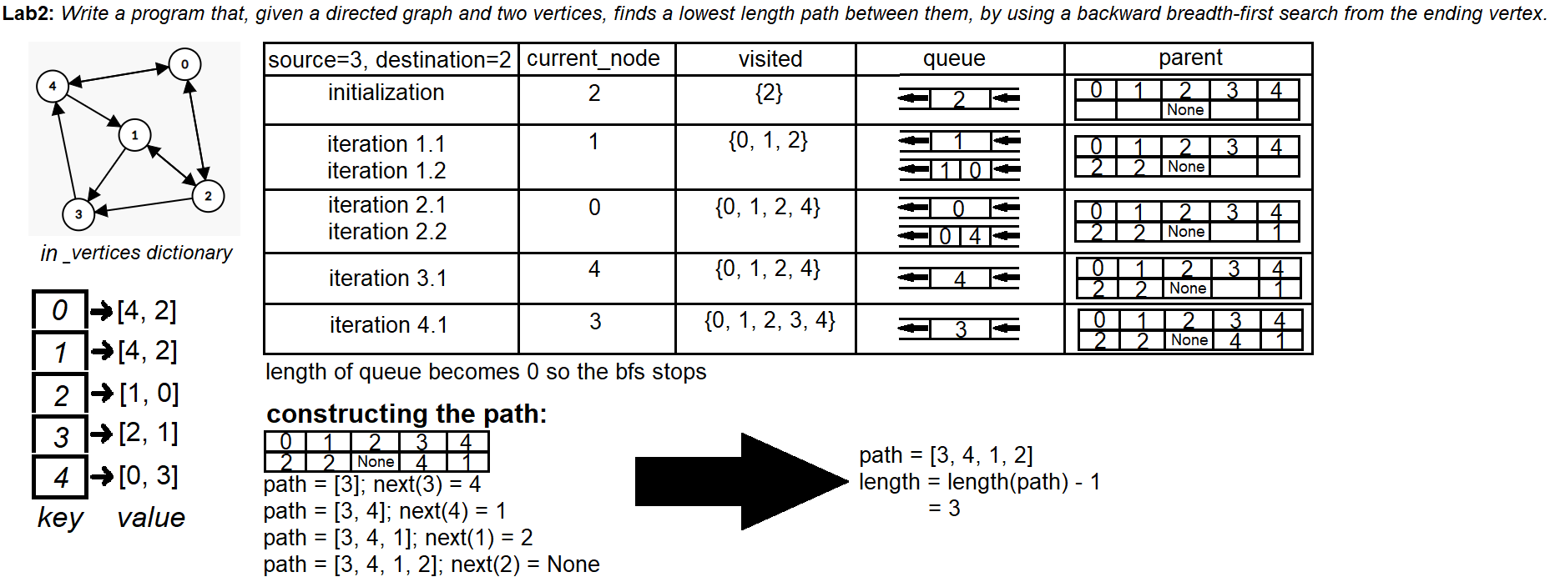Example 1 of a manual execution on a random directed graph with 5 vertices and 10 edges

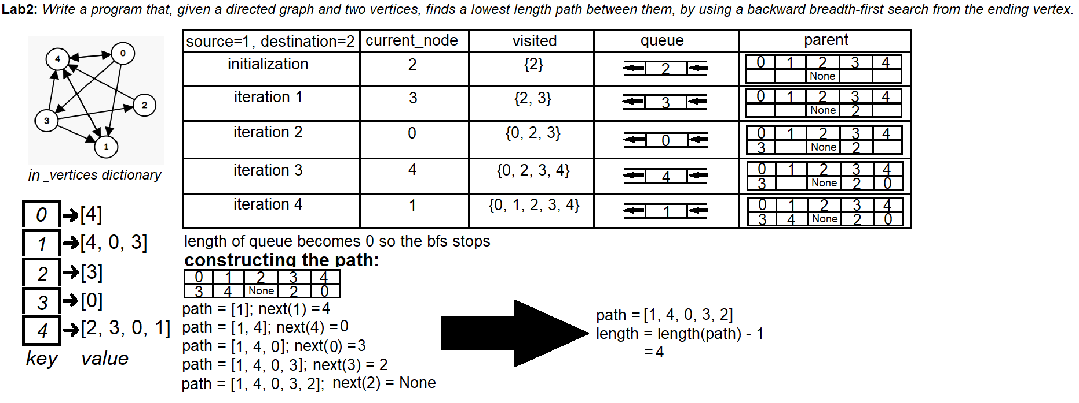Example 2 of a manual execution on a random directed graph with 5 vertices and 10 edges

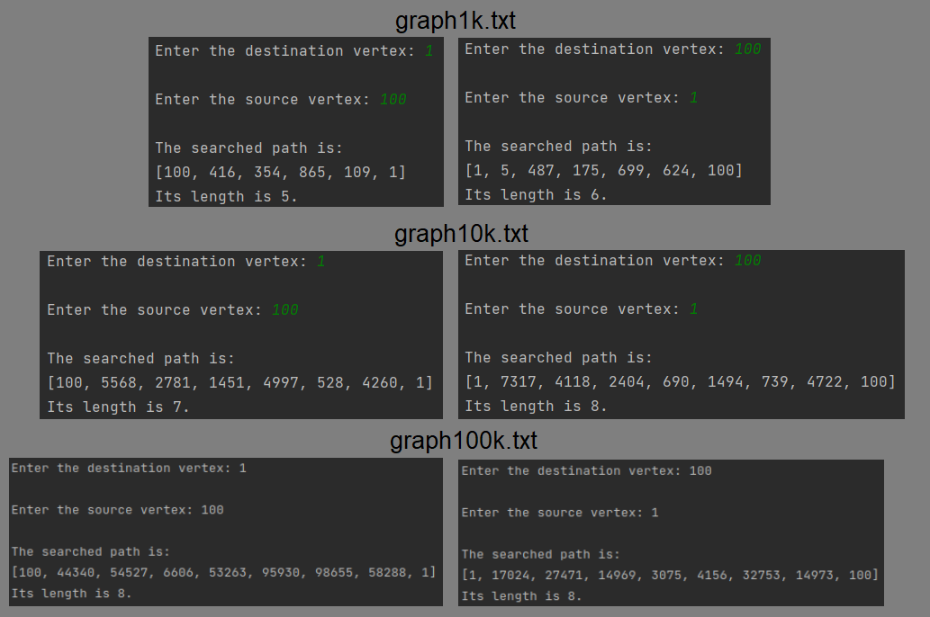The minimum length paths and their lengths from 1 to 100 and from 100 to 1 in graph1k, graph10k, graph100k.